CHART Virtual Training Forum (VTF) – Notes on Best Practices
Note: Updated information and resources gathered since these VTF notes were taken can be found on CHART’s COVID-19 Resource Page

Dining Room Closures, Curbside Pickup and Delivery
Wednesday, March 25, 2020

Dining Room Closures – How are you keeping to-go guests from sitting while they wait?
- Close the entire dining room and put the chairs up on the tables.
- Keep the dining room fully set so it looks open and inviting from outside but put up stanchions to block the dining area entrance.
- Move the dining room furniture out of room or against one of the walls.
- Rely on a host in the lobby to remind guests that all orders must be to-go.
Patios – How do you keep people from sitting on patio furniture, especially if immovable?
- Don’t use caution tape because it may look like something bad has happened.
- Put “Patio Closed” signs on the table and consider laminating them in case of bad weather.
- Have a manager keep an eye on the patio area and alert any guests who sit down that they cannot eat there for the time being.
- Lock side door from the restaurant to the patio to prevent guests from going out there.

Open – How are you letting guests know that you are open?
- Use A-frame signs, balloons, banners, lights, etc.
- Consider ignoring local bans/rules on signage right now and do whatever necessary to attract guests walking or driving by.
- Prop open front entrance doors (which also allows guests to enter without touching anything).

Sanitation – How are you keeping doors, credit card readers, etc. sterilized?
- Post a staff member at the door with gloves on to open door for everyone going in and out to eliminate germs on door handles.
- Instruct the team members to wipe down the credit card reader after each use.
- Try to encourage (or insist) that to-go orders are pre-paid online or over the phone.
- Install pick-up shelves in the guest area so that customers who have pre-ordered can grab their completed meals without touching anything.
- For walk-in guests waiting to order, use tape or paint on the floor to mark 6 feet apart to help them maintain social distancing while in line
- Limit the number of guests that can wait inside to pick up orders or tell them they can wait outside on the sidewalk or in their cars and you will bring the food to them.
- If the guests are coming via a drive-thru, your staff could hand off the to-go bags on a tray or pan to minimize contact.

Curbside – How are you identifying vehicle for each order?
- Consider signing up for an online ordering service such as ChowNow or SwipeBy.
- Ask for the guest’s make, model and color of car when order is placed.
- Reserve parking spots for pick-up and ask guests to text or call when they arrive.
- Parking spots for curbside pick-up can be marked with rudimentary signage for now, such as traffic cones or pylons with a stick and paper taped to it. Use whatever economical items your team can find at Home Depot to create these make-shift signs.
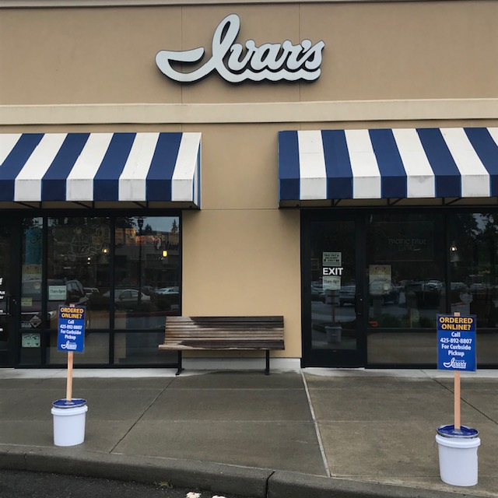
- For employees delivering curbside pick-up orders, instruct them to wear a new pair of gloves when delivering the food and ask the guest where to place the bags in the car (ideally it would be in the trunk or backseat to minimize contact).

Delivery – Who is delivering and what is involved?
- Most participants were using third-party delivery services, with the highest percentage of business from Door Dash and Uber Eats, followed by Grubhub in third place and Postmates a distant fourth.
- Selecting a third-party delivery service can depend on which ones will work with your current technology. There are services such as Chowly and It’s A Checkmate that can streamline operations and integrate directly with your POS (which removes the need for all the tablets on your front counter).
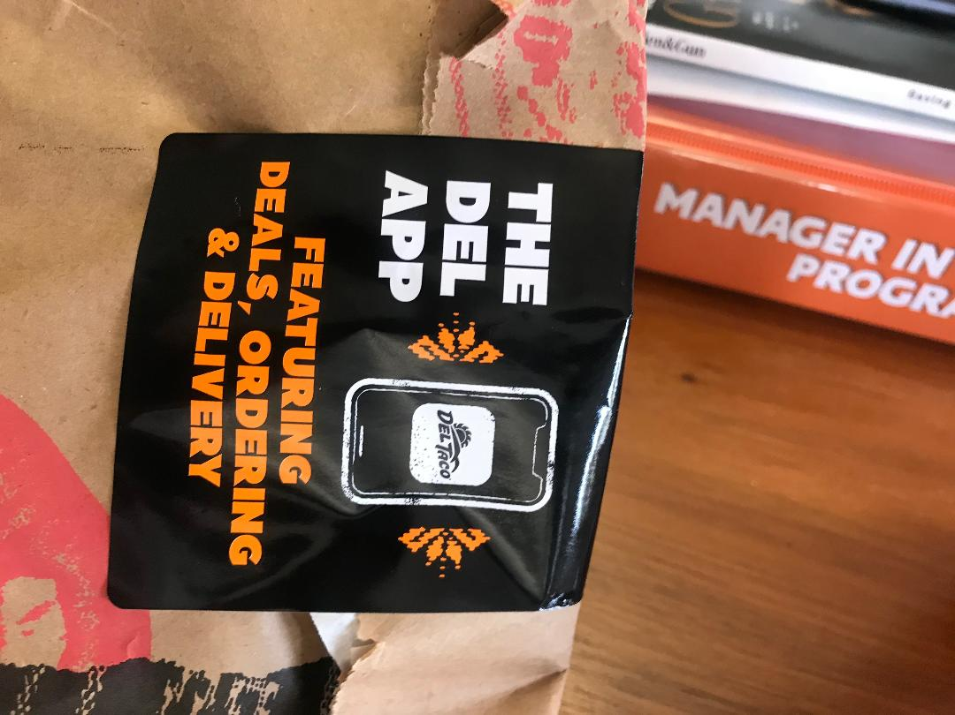
- Other participants have their own delivery drivers and are practicing “no-contact delivery” by dropping the food at the guest’s door and backing 6 feet away. With this system, tipping is only allowed in pre-pay.
- Some restaurants with delivery drivers require that their employees use their own car insurance and sign a waiver, and they may or may not do vehicle inspections each day (relaxed the rules only for this environment).
- For all delivered food, ask your marketing department to create tamper-proof stickers to seal delivery bags that have app and online order info.

